1.INTRODUCTION

1.1 project overview

* There are **'cardboard', 'compost', 'glass', 'metal', 'paper', 'plastic', 'trash'** total 7 different types of waste materials which are use for recycling.
* Here i have 2187 images belonging 7 classes.
* Here i have trained dataset using VGG16,RESNET50 model via using Transfer Learning technique of CNN for classification.
* Here i have trained this model till 5 epochs and i got 69.77% accuracy. Since my computer cannot afford more epochs at this time due unavailability of GPU. If you have good amount of group you can train more than 50 epochs.

2.IDEATION AND PROPOSED SOLUTION

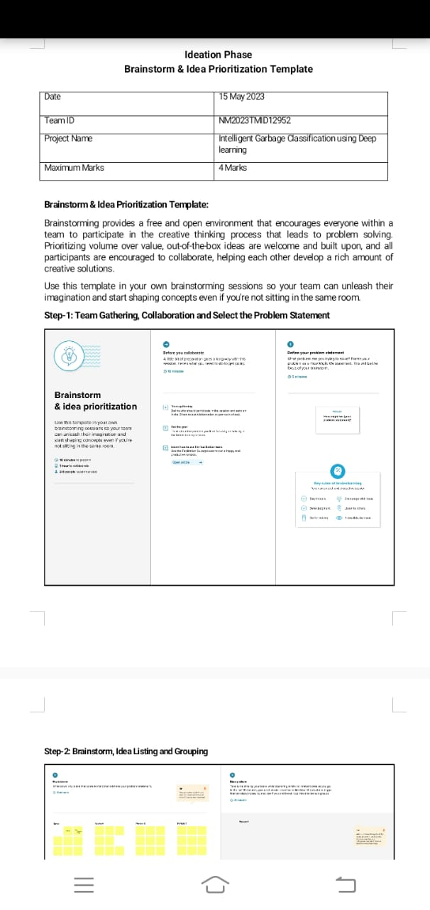

2.1 Problem Statement definition

The problem is prity much straight forward, we all are familier with Garbage and waste material which is very harmful for our society.if we talk about amount of waste then the world almost generates at least 5 million tons of waste per day and this number is still increasing day by day that's why we need to aware about waste. This model which help us to classify waste with 7 different waste materials and it will show you the details of that particular waste materials. This will help to raise awareness for people to reduce and recycle waste.

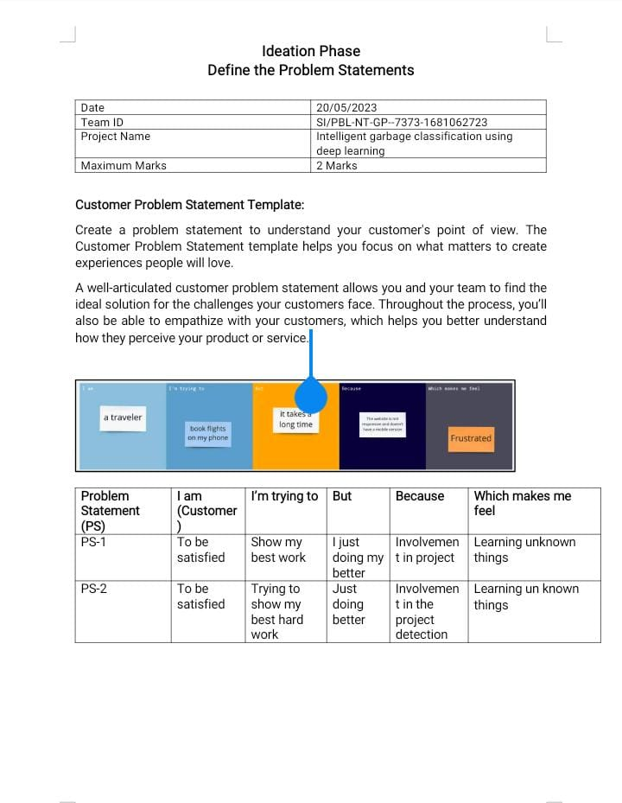

2.2 Empathy map canvas

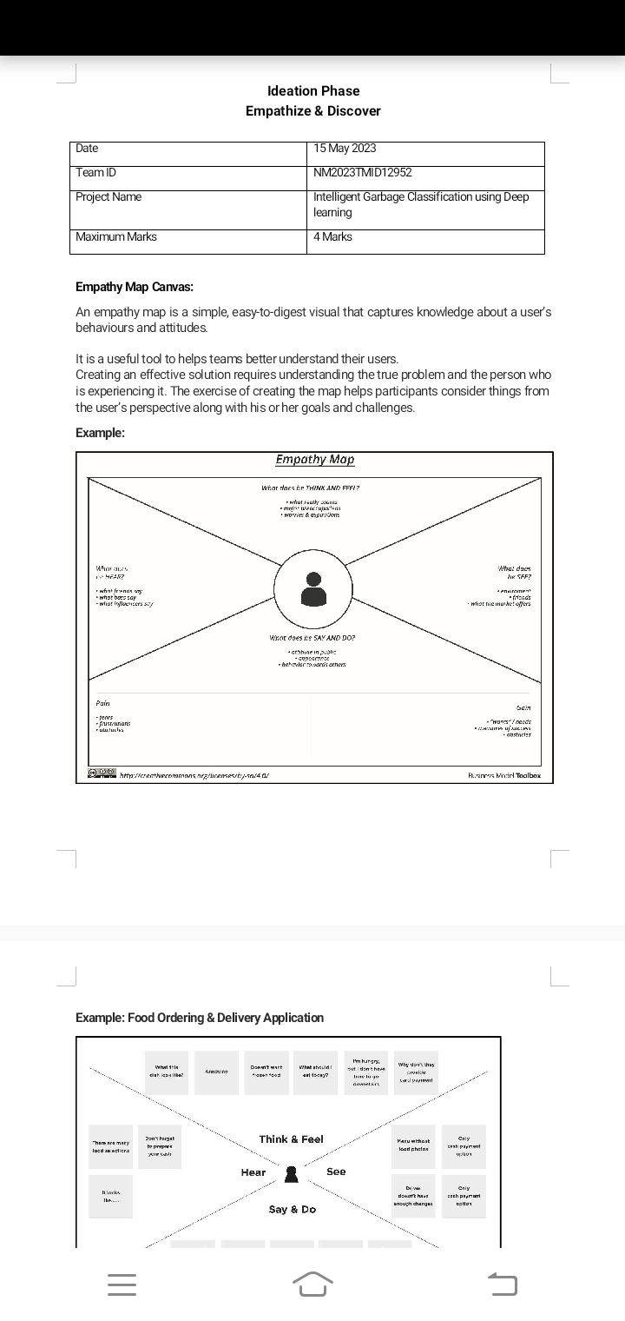

3.REQUIREMENT ANALSIS

3.1 Functional requirement

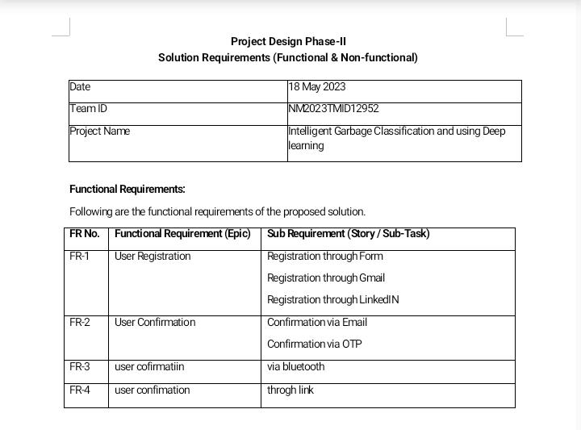

3.2 Non-Functional requirements

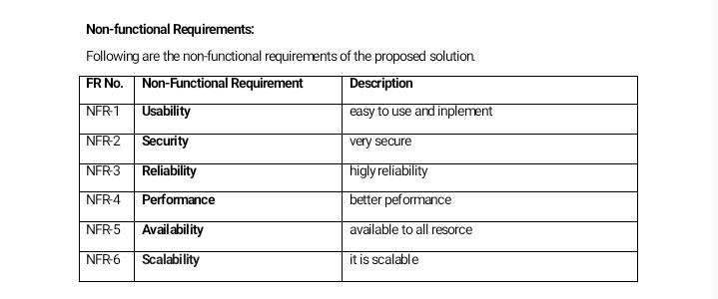

4. PROJECT DESIGN

4.1 Data Flow Diagrams

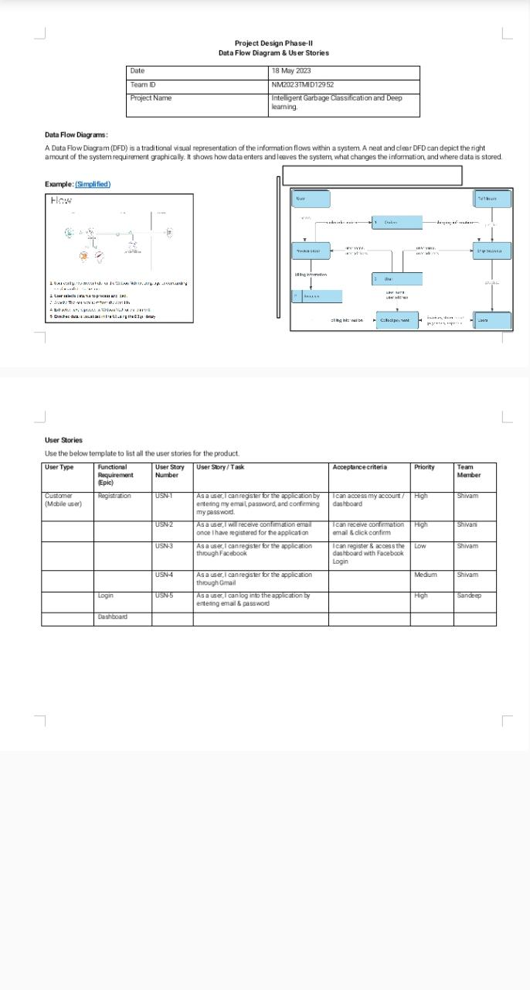

4.2 Solution & Technical Architecture

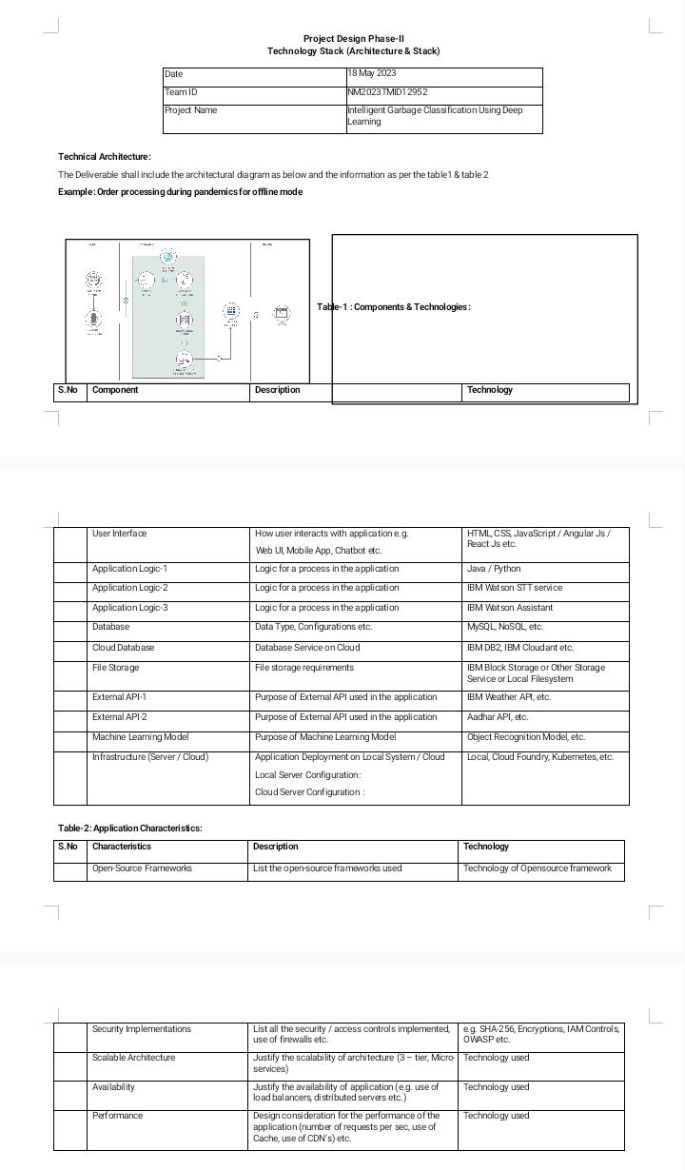

4.3 User Stories

1. Addressing Food Waste.
2. Ridding the world of plastic waste.
3. Boosting the circular economy.
4. Singapore steps up efforts.
5. Canada’s waste dumping in Philippines.

5.RESULT

5.1Performance metrics

Performance metrics, or PMs, are measured within a certain area of a business. This tends to be against a predesigned goal. That means that you receive a broader range of data than a key performance indicator, or KPI.

A KPI will use a specific metric to measure performance.

For example, a PM could measure the [productivity](https://www.freshbooks.com/timesheets-and-time-tracking) of the warehouse and shipping department compared to a set goal. Whereas a KPI would measure how fast the warehouse and shipping department can turn an order into a delivery

6.ADVANTAGES & DISADVANTAGES

6.1 Advantages

* **Saving energy and natural resources in producing new materials**. 80% of urban waste can be used, so its classification would reduce the need to extract raw material.
* Contributing**to job creation.** According to the UN, the recycling sector employs **12 million people** in the United States, China, and Brazil alone as a result of waste classification.
* **Reducing pollution from depositing and burning waste in landfills**by reincorporating waste in the domestic, industrial, and commercial circuits.
* Properly managing waste that **prevents the dispersion of dangerous substances** and, thus, conserving raw materials and living beings

6.2 Disadvantages

### 1. High upfront capital costs

### 2. Recycling sites are always unhygienic, unsafe and unsightly

### 3. Products from recycled waste may not be durable

### 4. Recycling might not be inexpensive

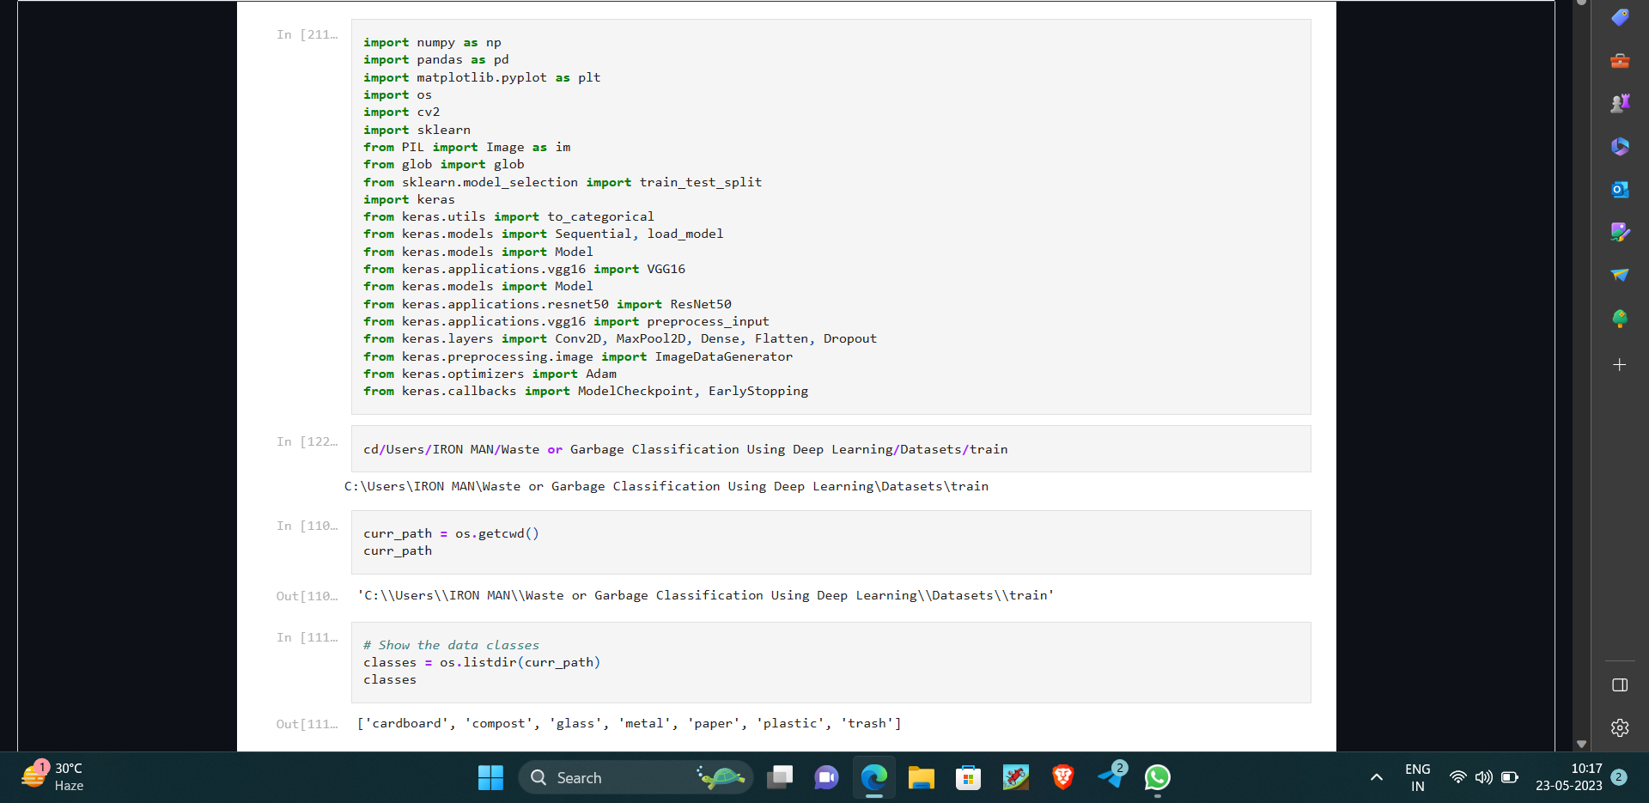

### 5. Recycling is not widespread on large scale

**7.Source code**

